Date: / / 2025

Lab Practical #03:
Design a simple Music App (3 screens) using Basic Tools Position, Size, Rotation, Color Styles, Masks.

Practical Assignment #03:
Design the 'Login Screen'. Focus on tools from Position, Size, Rotation, Color Styles, Masks

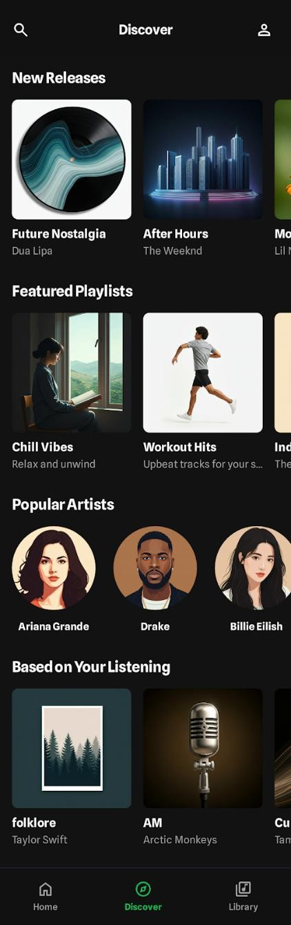
Description:

Home Screen

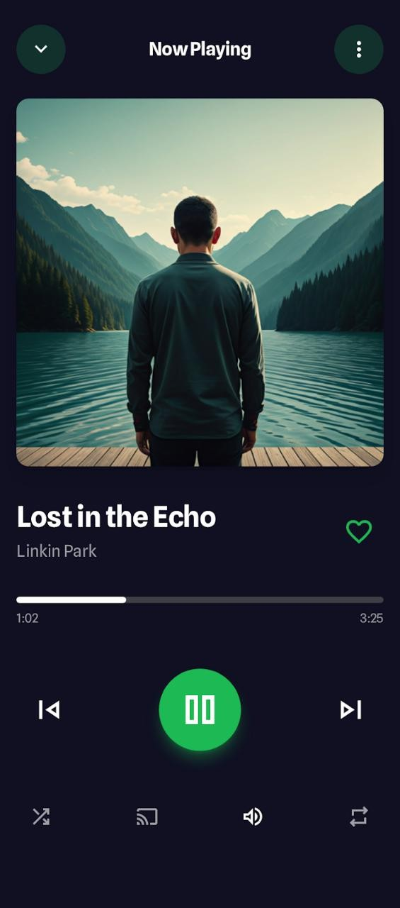
Now Playing – Screen
Date: / / 2025

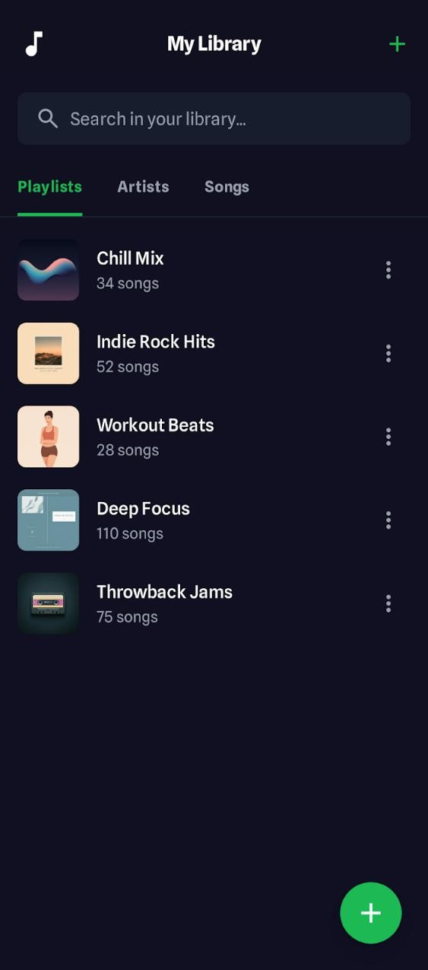

Library- Screen
Date: / / 2025

